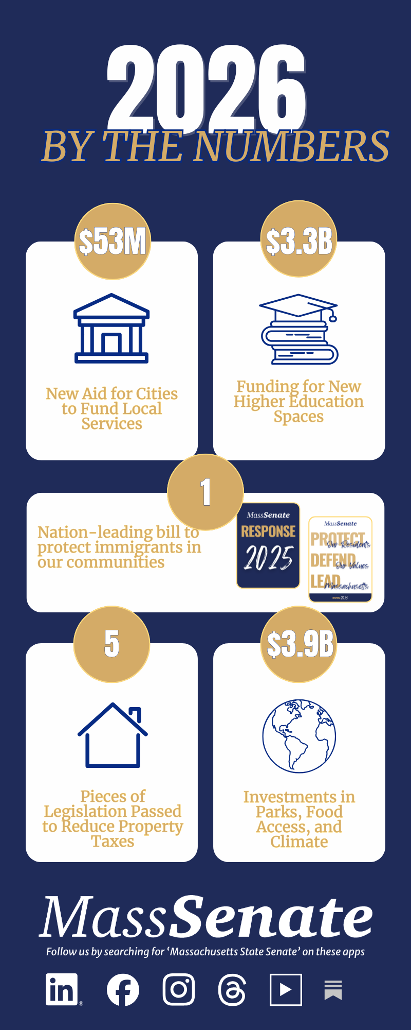
Massachusetts State Senate
2026 Progress Report

Trends

- Our work in 2026 has centered on lowering costs for residents—making investments in housing, transportation, education, and child care to ease the burden on families.

- In response to harmful federal actions, the Senate has taken steps to protect health care access, defend civil rights, and support vulnerable communities across the Commonwealth.

- From historic local aid to once-in-a-generation investments in climate resilience, infrastructure, and food systems, the Senate is making strategic investments to strengthen communities now and into the future.

Highlights

- Delivered a fiscally responsible Fiscal Year 2027 budget that invests in education, transportation, and health care while maintaining the Commonwealth’s strong financial footing.

- Increased local aid to cities and towns to help meet rising costs and maintain essential services.

- Passed the Mass Ready Act, a landmark environmental bond bill that invests billions to protect clean drinking water, reduce plastic waste, and help communities prepare for flooding and extreme weather.

- Modernized Massachusetts cannabis laws, improving safety, reducing unnecessary barriers for businesses, and expanding opportunity in a growing industry.

- Advanced the FARM Bill, making it easier for families to access fresh, local food while supporting Massachusetts farmers and protecting our food supply for the future.

